# Security:

* S-1 Risk: End user want to ensure the pictures taken of personal information doesn’t fall into the wrong hands.
* S-1 Mitigation: During the feedback stage after a move, have the end user have the ability to delete personal information collected during the move.
* S-2 Risk: End user wants to ensure his/her data isn’t being collected for nefarious purposes.
* S-2 Mitigation: Allow the end user to opt out of the analytics program inside of the user settings and disclose what his/her data is being used for.

|  |  |  |  |  |  |  |
| --- | --- | --- | --- | --- | --- | --- |
| Probability | | | | | | |
|  |  | Very Low | Low | Medium | High | Very High |
| Severity | Very High |  |  |  |  |  |
| High |  |  |  |  |  |
| Medium |  |  |  |  |  |
| Low |  | S-1, S-2 |  |  |  |
| Very Low |  |  |  |  |  |
| Acceptable: Risk is acceptable level.  Permissible: Risk is okay for now and can be fixed at a later date.  Considerable: Risk is noted and will be fixed in the next iteration.  Catastrophic: Product is placed on hold until issue is fixed. | | | | | | |

# Technical

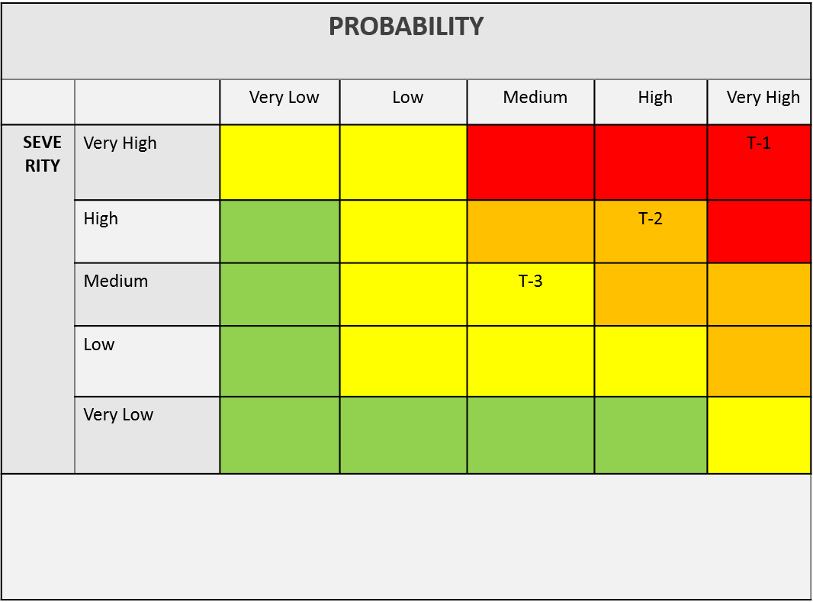

* T-1: Current technology involving computer vision is a challenge.
* T-1 Mitigation: Conduct a prototype to mitigate risk of critical errors upon release.
* T-2: Artificial Intelligence prone to error due to insufficient training data.
* T-2 Mitigation: Implementing a feedback loopback in the beta phase with test users.
* T-3: Challenge to obtain accurate and timely feedback.
* T-3 Mitigation: Implement a feature for users to give feedback if the application operated correctly after completing a move.

# Customer

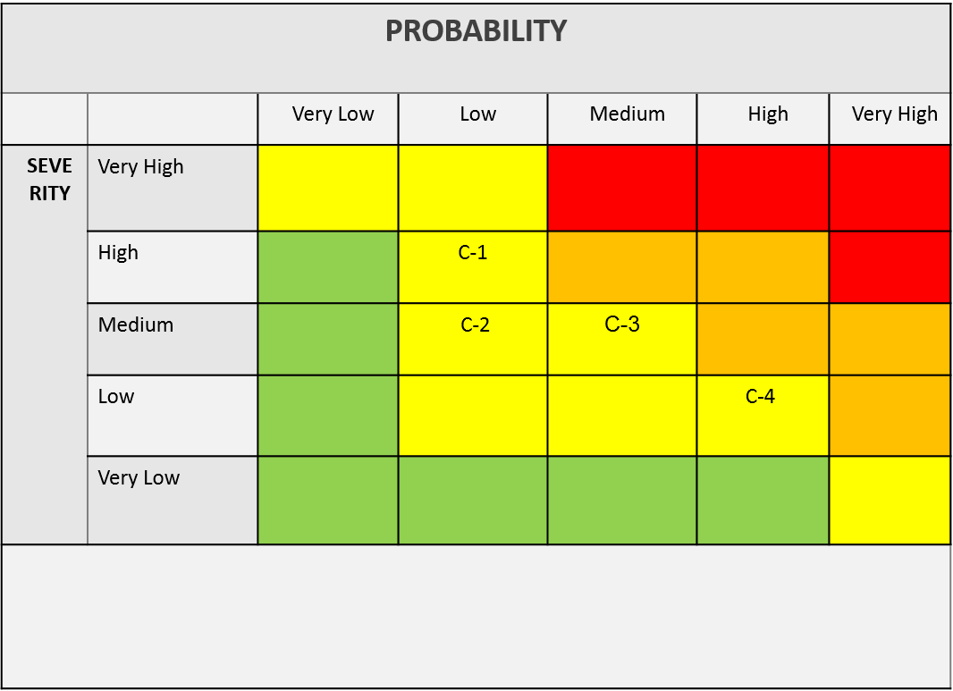



* C-1: End user is inexperienced with the application.
* C-1 Mitigation: Implement a tutorial on how to use the application and provide a help feature.
* C-2: End user finds UI challenging to operate.
* C-2: Mitigation: Implement analytics for tracking when a user stop using the application.
* C-3: End users are not satisfied with the recommendations of the application.
* C-3 Mitigation: Implement a customer feedback feature that allows the users to disclose his/her issues with the applications.
* C-4: End user doesn’t follow the guidelines of the application.
* C-4 Mitigation: Implement a feature that allows the user to repeat/reset certain steps in the application as they progress.